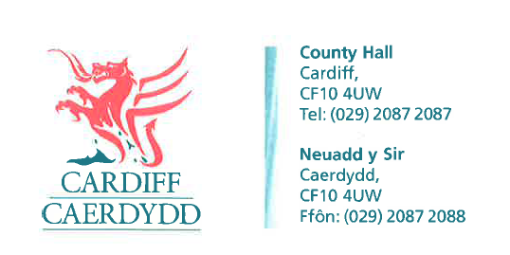
FOI Response Document
FOI18157
Thank you for your request under the Freedom of Information Act 2000 about Parking Fines received on 20/07/2022.
Request
1. Which are the six streets in Cardiff that have seen the highest number of parking fines between June 2021 and June 2022?
Response: Cardiff Council can confirm the 6 streets seeing the highest number of parking fines in the table below.
Street Name | Number of Fines issued | Amount Accumulated
City Road | 865 | £26,159
Rhymney Street | 846 | £28, 409
Mackintosh Place | 826 | £23, 483
Wellfield Place | 818 | £26, 668
Churchill Way | 733 | £22, 301
Bute Crescent | 701 | £21, 988

2. How many parking fines were accumulated on each of these streets during the same period?
Response: Please see the table in the response to Q1.
3. How much money was accumulated through parking fines on each of these streets during the same period?
Response: Please see the table in the response to Q1.

If you have any queries or concerns, please do not hesitate to contact us.
Please remember to quote the reference number above in any future communications.

